Array Assignment

- Write a program that asks the user to take array of 10 integers. The program must compute and write how many integers are greater than or equal to 10.

int main() {
const int size = 10;
int arr[size];

// Input array elements from the user
cout << "Enter " << size << " integers:" << endl;
for (int i = 0; i < size; ++i) {
cout << "Enter integer " << i + 1 << ": ";
cin >> arr[i];
}

// Compute the count of integers greater than or equal to 10
int count = 0;
for (int i = 0; i < size; ++i) {
if (arr[i] >= 10) {
count++;
}
}

// Output the result
cout << "Number of integers greater than or equal to 10: " << count << endl;

return 0;
}
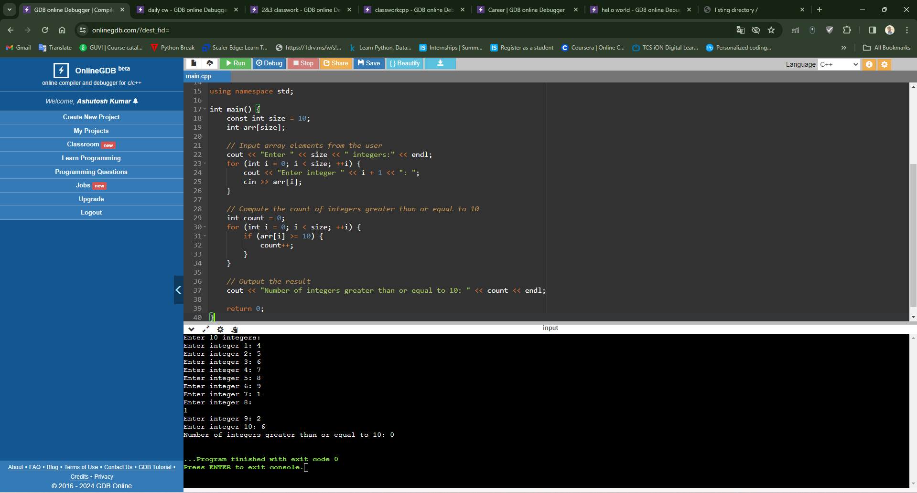

- Write a program that asks the user to take array of 10 integers. The program must output the largest element in the array, and the index at which that element was found.

// 2. Write a program that asks the user to take array of 10 integers.
// The program must output the largest element in the array,
// and the index at which that element was found.

#include <iostream>

using namespace std;

int main() {
const int size = 10;
int arr[size];

// Input array elements from the user
cout << "Enter " << size << " integers:" << endl;
for (int i = 0; i < size; ++i) {
cout << "Enter integer " << i + 1 << ": ";
cin >> arr[i];
}

// Find the largest element and its index
int maxElement = arr[0];
int maxIndex = 0;
for (int i = 1; i < size; ++i) {
if (arr[i] > maxElement) {
maxElement = arr[i];
maxIndex = i;
}
}

// Output the result
cout << "Largest element: " << maxElement << endl;
cout << "Index of largest element: " << maxIndex << endl;

return 0;
}
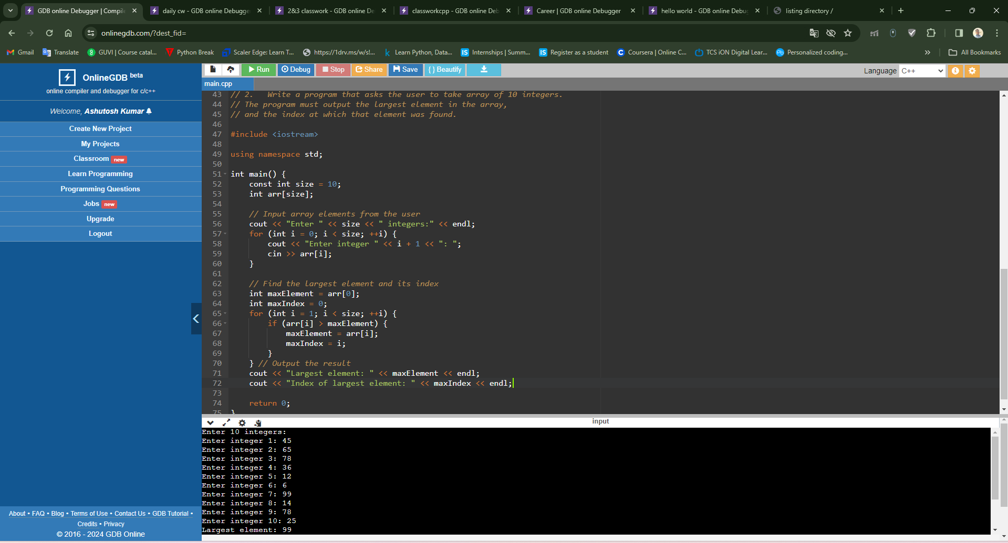
- Write a program that asks the user to take array of 10 integers. The program will then sort the array in descending order and display it.
#include <iostream>
#include <algorithm>

using namespace std;

int main() {
const int size = 10;
int arr[size];

// Input array elements from the user
cout << "Enter " << size << " integers:" << endl;
for (int i = 0; i < size; ++i) {
cout << "Enter integer " << i + 1 << ": ";
cin >> arr[i];
}

// Sort the array in descending order
sort(arr, arr + size, greater<int>());

// Output the sorted array
cout << "Sorted array in descending order:" << endl;
for (int i = 0; i < size; ++i) {
cout << arr[i] << " ";
}
cout << endl;

return 0;
}
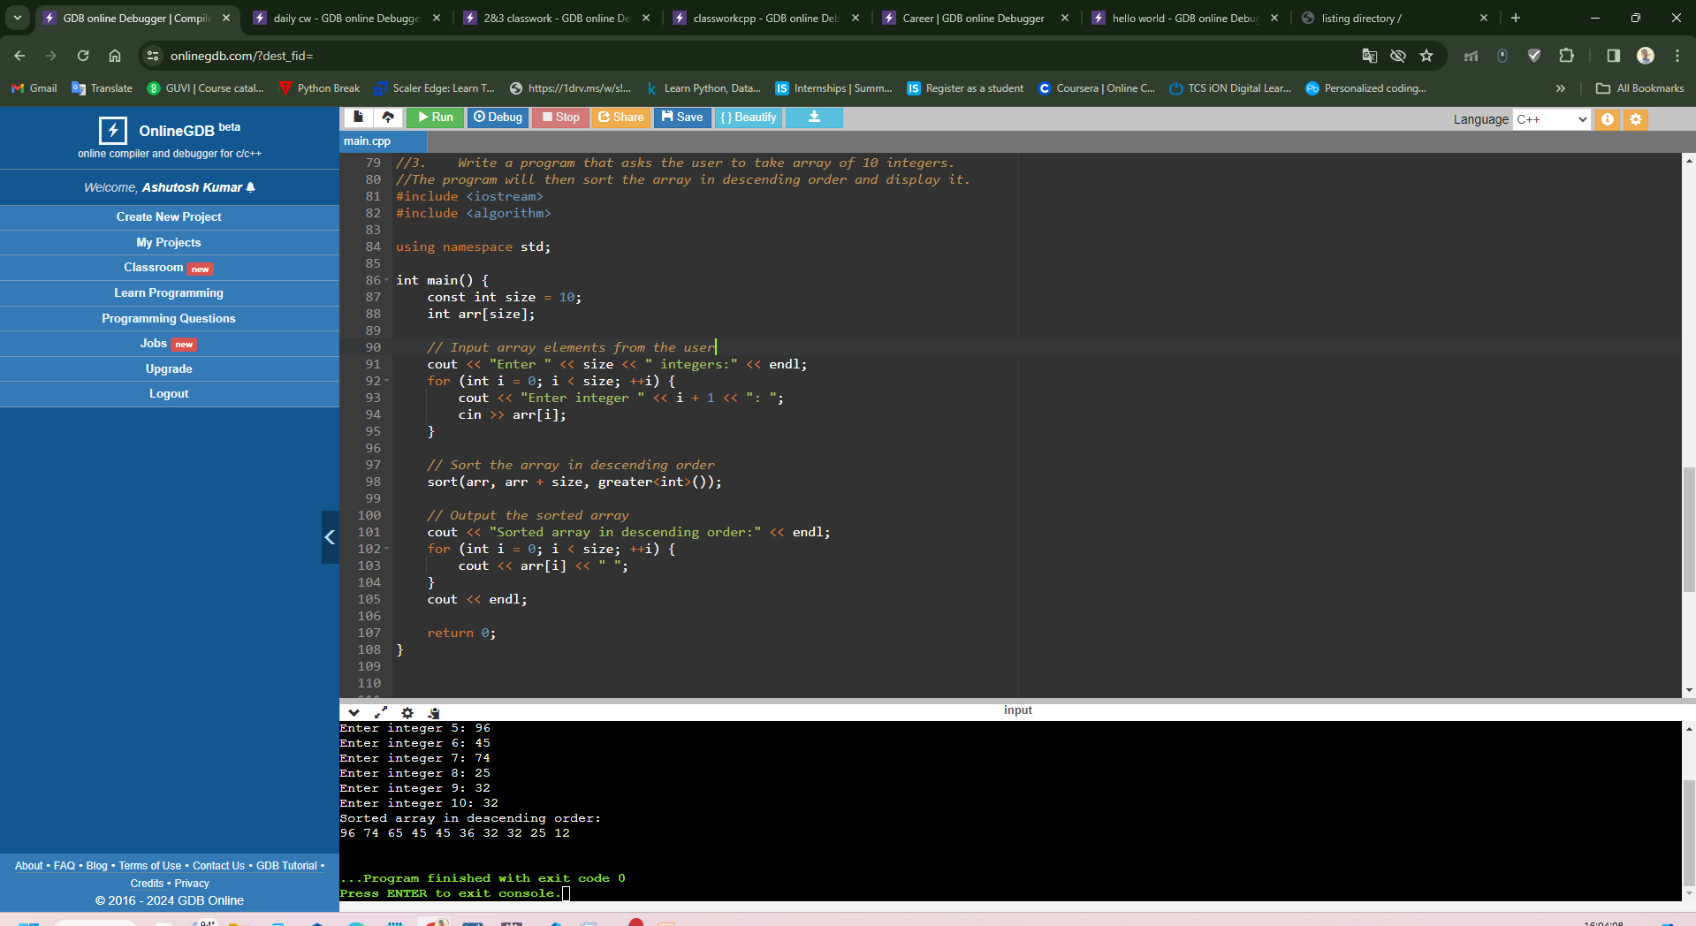
- Write a program that asks the user to take array of 10 integers. The program will then display either "the array is growing", "the array is decreasing", "the array is constant", or "the array is growing and decreasing."

#include <iostream>
using namespace std;

int main() {
const int size = 10;
int arr[size];

// Input array elements from the user
cout << "Enter " << size << " integers:" << endl;
for (int i = 0; i < size; ++i) {
cout << "Enter integer " << i + 1 << ": ";
cin >> arr[i];
}

// Check if the array is growing, decreasing, constant, or both
bool isGrowing = true, isDecreasing = true;
for (int i = 1; i < size; ++i) {
if (arr[i] > arr[i - 1]) {
isDecreasing = false;
} else if (arr[i] < arr[i - 1]) {
isGrowing = false;
}
}

// Output the result based on the flags
if (isGrowing && isDecreasing) {
cout << "The array is growing and decreasing." << endl;
} else if (isGrowing) {
cout << "The array is growing." << endl;
} else if (isDecreasing) {
cout << "The array is decreasing." << endl;
} else {
cout << "The array is constant." << endl;
}

return 0;
}

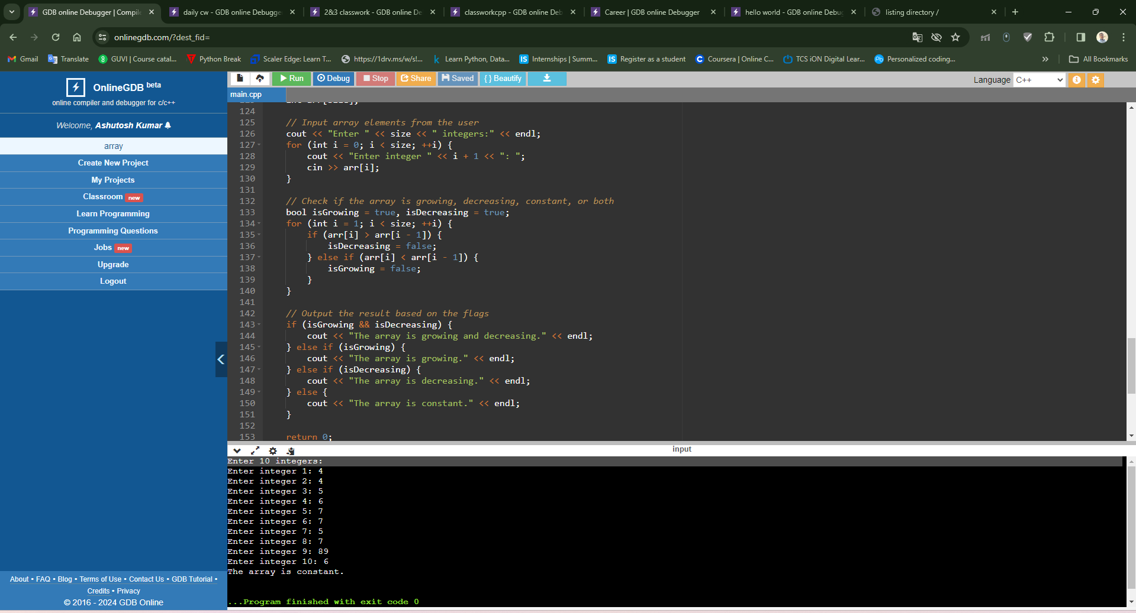
- Write a program which takes 2 arrays of 10 integers each, a and b. c is an array with 20 integers. The program should put into c the appending of b to a, the first 10 integers of c from array a, the latter 10 from b. Then the program should display c.
#include <iostream>

using namespace std;

int main() {
const int size = 10;
int a[size], b[size], c[size * 2];

// Input array 'a'
cout << "Enter " << size << " integers for array 'a':" << endl;
for (int i = 0; i < size; ++i) {
cout << "Enter integer " << i + 1 << ": ";
cin >> a[i];
}

// Input array 'b'
cout << "Enter " << size << " integers for array 'b':" << endl;
for (int i = 0; i < size; ++i) {
cout << "Enter integer " << i + 1 << ": ";
cin >> b[i];
}

// Append 'b' to 'a' to create array 'c'
for (int i = 0; i < size; ++i) {
c[i] = a[i];
c[i + size] = b[i];
}

// Display array 'c'
cout << "Array 'c' (appended array):" << endl;
for (int i = 0; i < size * 2; ++i) {
cout << c[i] << " ";
}
cout << endl;

return 0;
}

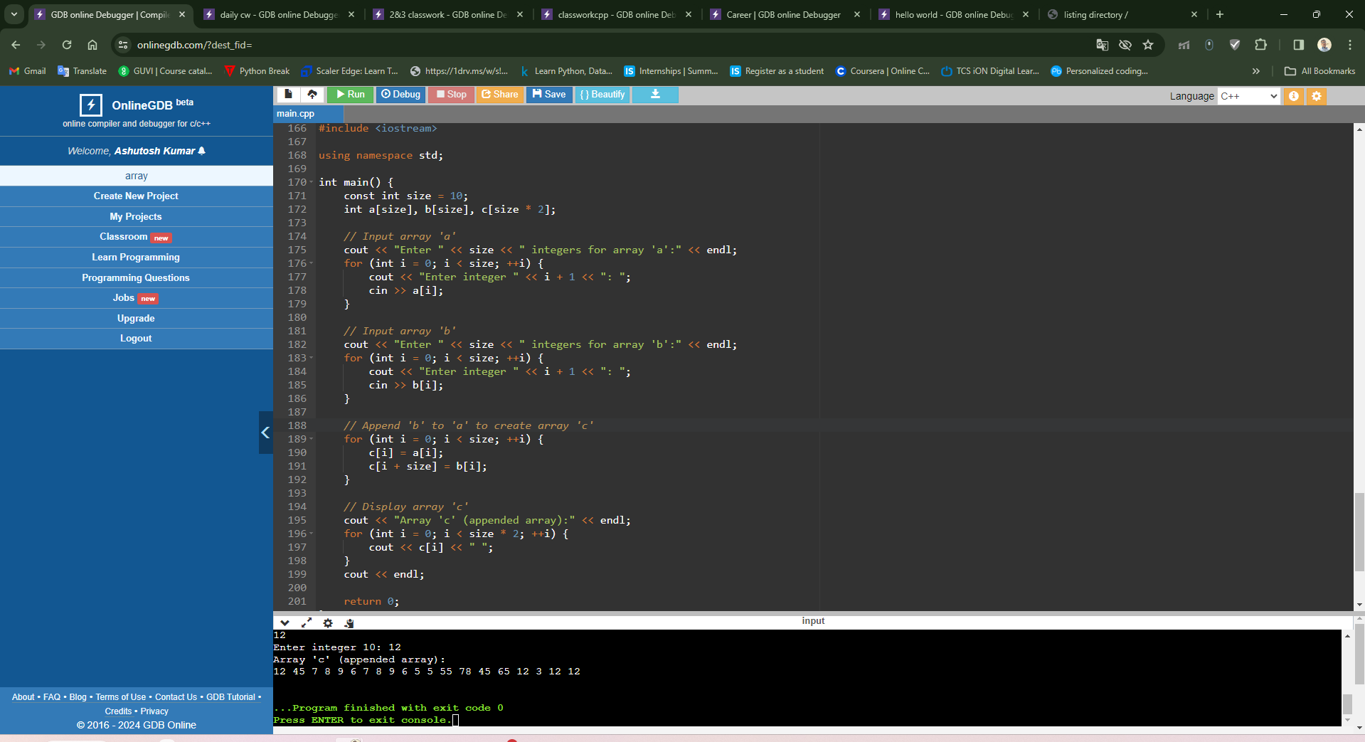
- Write a program that asks the user to take an array of 10 integer and an integer value V and an index value i between 0 and 9. The program must put the value V at the place i in the array, shifting each element right and dropping off the last element. The program must then write the final array.
#include <iostream>

using namespace std;

int main() {
const int size = 10;
int arr[size];
int V, i;

// Input array of 10 integers
cout << "Enter " << size << " integers for the array:" << endl;
for (int j = 0; j < size; ++j) {
cout << "Enter integer " << j + 1 << ": ";
cin >> arr[j];
}

// Input integer value V
cout << "Enter an integer value V: ";
cin >> V;

// Input index value i between 0 and 9
cout << "Enter an index value i between 0 and 9: ";
cin >> i;
if (i < 0 || i >= size) {
cout << "Invalid index value. Please enter an index value between 0 and 9." << endl;
return 1;
}

// Shift elements to the right and drop the last element
for (int j = size - 1; j > i; --j) {
arr[j] = arr[j - 1];
}

// Put value V at index i
arr[i] = V;

// Write the final array
cout << "Final array after inserting V at index i:" << endl;
for (int j = 0; j < size; ++j) {
cout << arr[j] << " ";
}
cout << endl;

return 0;
}
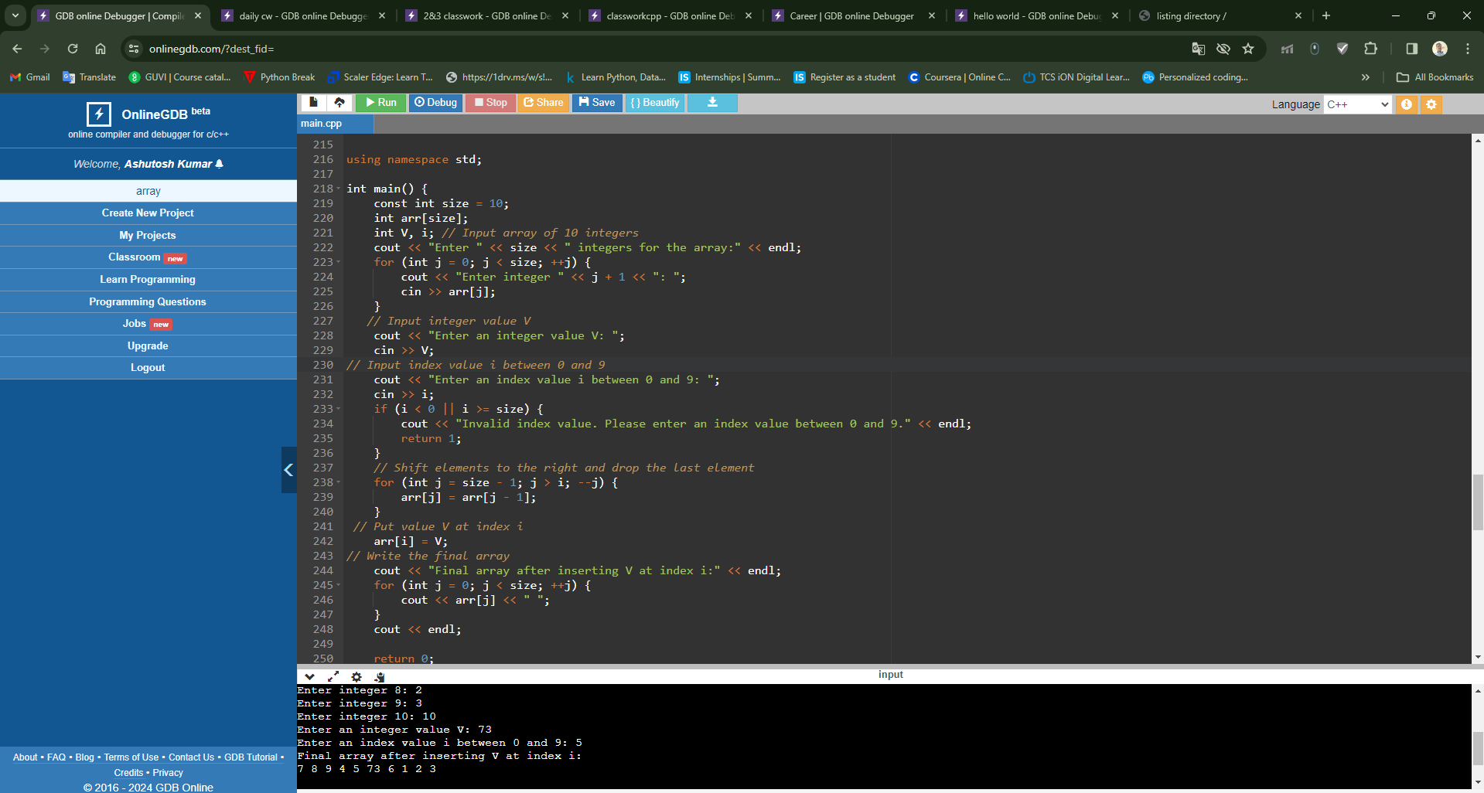

- Write a program to handle the command line arguments entered by the user.
#include <iostream>

using namespace std;

int main(int argc, char* argv[]) {
// Display the number of command line arguments
cout << "Number of command line arguments: " << argc << endl;

// Display each command line argument
cout << "Command line arguments:" << endl;
for (int i = 0; i < argc; ++i) {
cout << "Argument " << i << ": " << argv[i] << endl;
}

return 0;
}
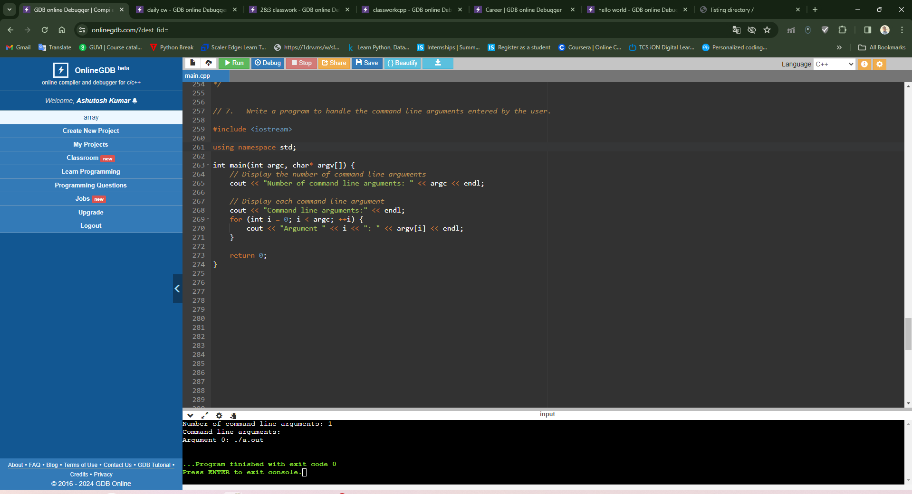

- Write a program to add 2 matrices.

#include <iostream>
using namespace std;

const int ROWS = 2;
const int COLS = 2;

void addMatrices(int mat1[][COLS], int mat2[][COLS], int result[][COLS]) {
for (int i = 0; i < ROWS; ++i) {
for (int j = 0; j < COLS; ++j) {
result[i][j] = mat1[i][j] + mat2[i][j];
}
}
}

void displayMatrix(int mat[][COLS]) {
for (int i = 0; i < ROWS; ++i) {
for (int j = 0; j < COLS; ++j) {
cout << mat[i][j] << " ";
}
cout << endl;
}
}

int main() {
int mat1[ROWS][COLS] = {{1, 2},
{3, 4}};
int mat2[ROWS][COLS] = {{5, 6},
{7, 8}};
int result[ROWS][COLS];

// Adding matrices
addMatrices(mat1, mat2, result);

// Displaying matrices
cout << "Matrix 1:" << endl;
displayMatrix(mat1);
cout << endl;

cout << "Matrix 2:" << endl;
displayMatrix(mat2);
cout << endl;

cout << "Resultant Matrix after addition:" << endl;
displayMatrix(result);

return 0;
}
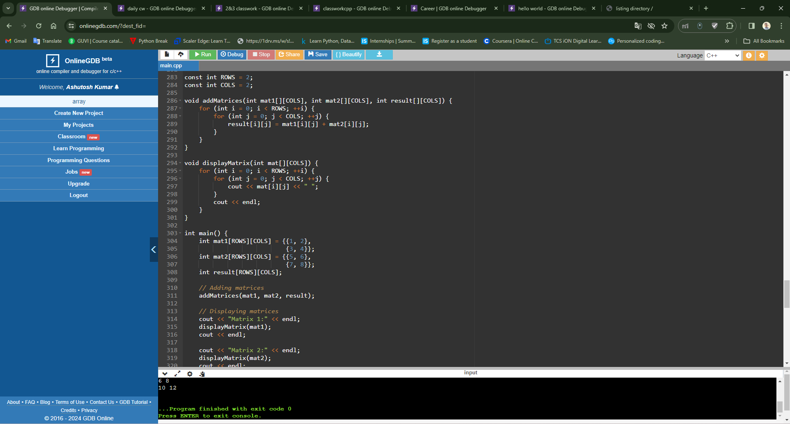

9. Write a program to multiply 2 matrices.
#include <iostream>
using namespace std;

const int ROWS1 = 2;
const int COLS1 = 2;
const int ROWS2 = 2;
const int COLS2 = 2;

void multiplyMatrices(int mat1[][COLS1], int mat2[][COLS2], int result[][COLS2]) {
for (int i = 0; i < ROWS1; ++i) {
for (int j = 0; j < COLS2; ++j) {
result[i][j] = 0;
for (int k = 0; k < COLS1; ++k) {
result[i][j] += mat1[i][k] * mat2[k][j];
}
}
}
}

void displayMatrix(int mat[][COLS2]) {
for (int i = 0; i < ROWS1; ++i) {
for (int j = 0; j < COLS2; ++j) {
cout << mat[i][j] << " ";
}
cout << endl;
}
}

int main() {
int mat1[ROWS1][COLS1] = {{1, 2},
{3, 4}};
int mat2[ROWS2][COLS2] = {{5, 6},
{7, 8}};
int result[ROWS1][COLS2];

// Multiplying matrices
multiplyMatrices(mat1, mat2, result);

// Displaying matrices
cout << "Matrix 1:" << endl;
displayMatrix(mat1);
cout << endl;

cout << "Matrix 2:" << endl;
displayMatrix(mat2);
cout << endl;

cout << "Resultant Matrix after multiplication:" << endl;
displayMatrix(result);

return 0;
}

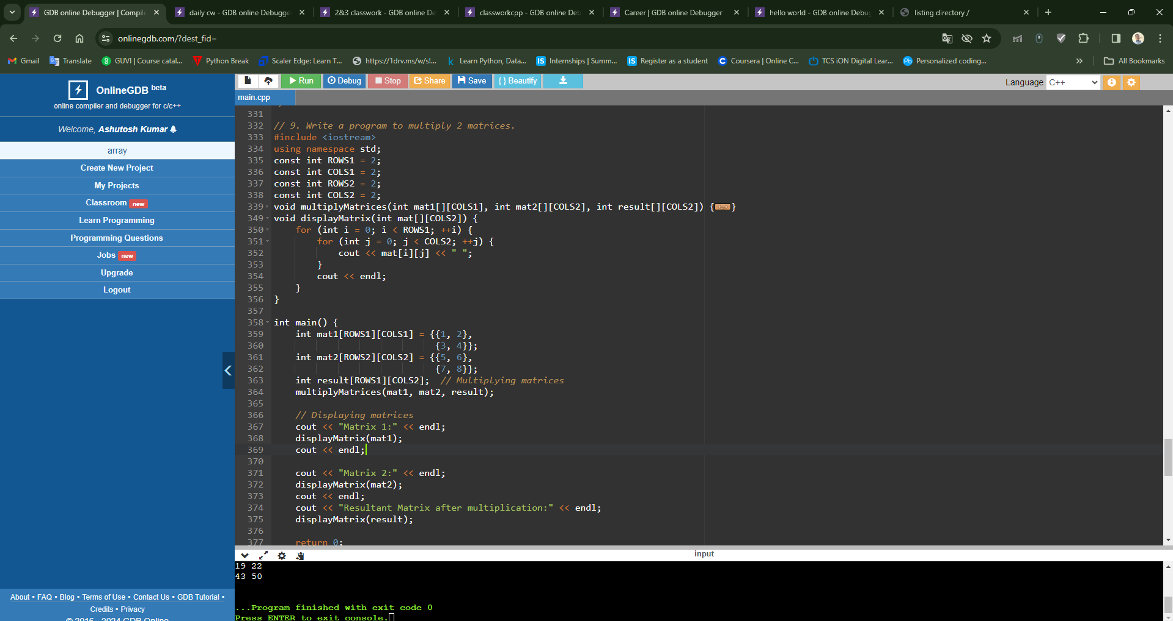
C++ ASSIGNMENT 5 (STRING HANDLING)

// 1. Write a program to find the length of string.

#include <iostream>
using namespace std;

int main() {
char str[100];
cout << "Enter a string: ";
cin.getline(str, 100);

int length = 0;
while (str[length] != '\0') {
length++;
}

cout << "Length of the string: " << length << endl;
return 0;
}

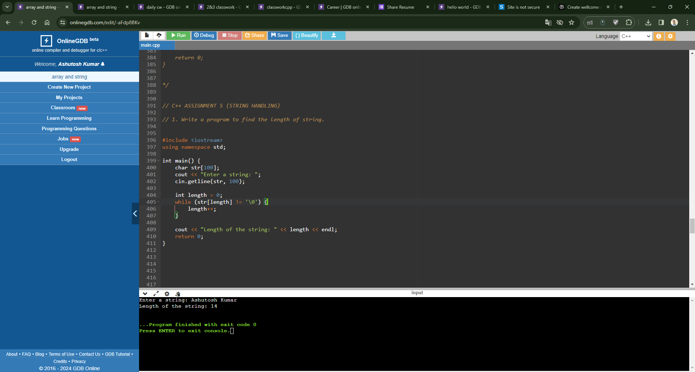

//2. Write a program to display string from backward.

#include <iostream>
using namespace std;

int main() {
char str[100];
cout << "Enter a string: ";
cin.getline(str, 100);

int length = 0;
while (str[length] != '\0') {
length++;
}

cout << "String in reverse: ";
for (int i = length - 1; i >= 0; i--) {
cout << str[i];
}
cout << endl;

return 0;
}

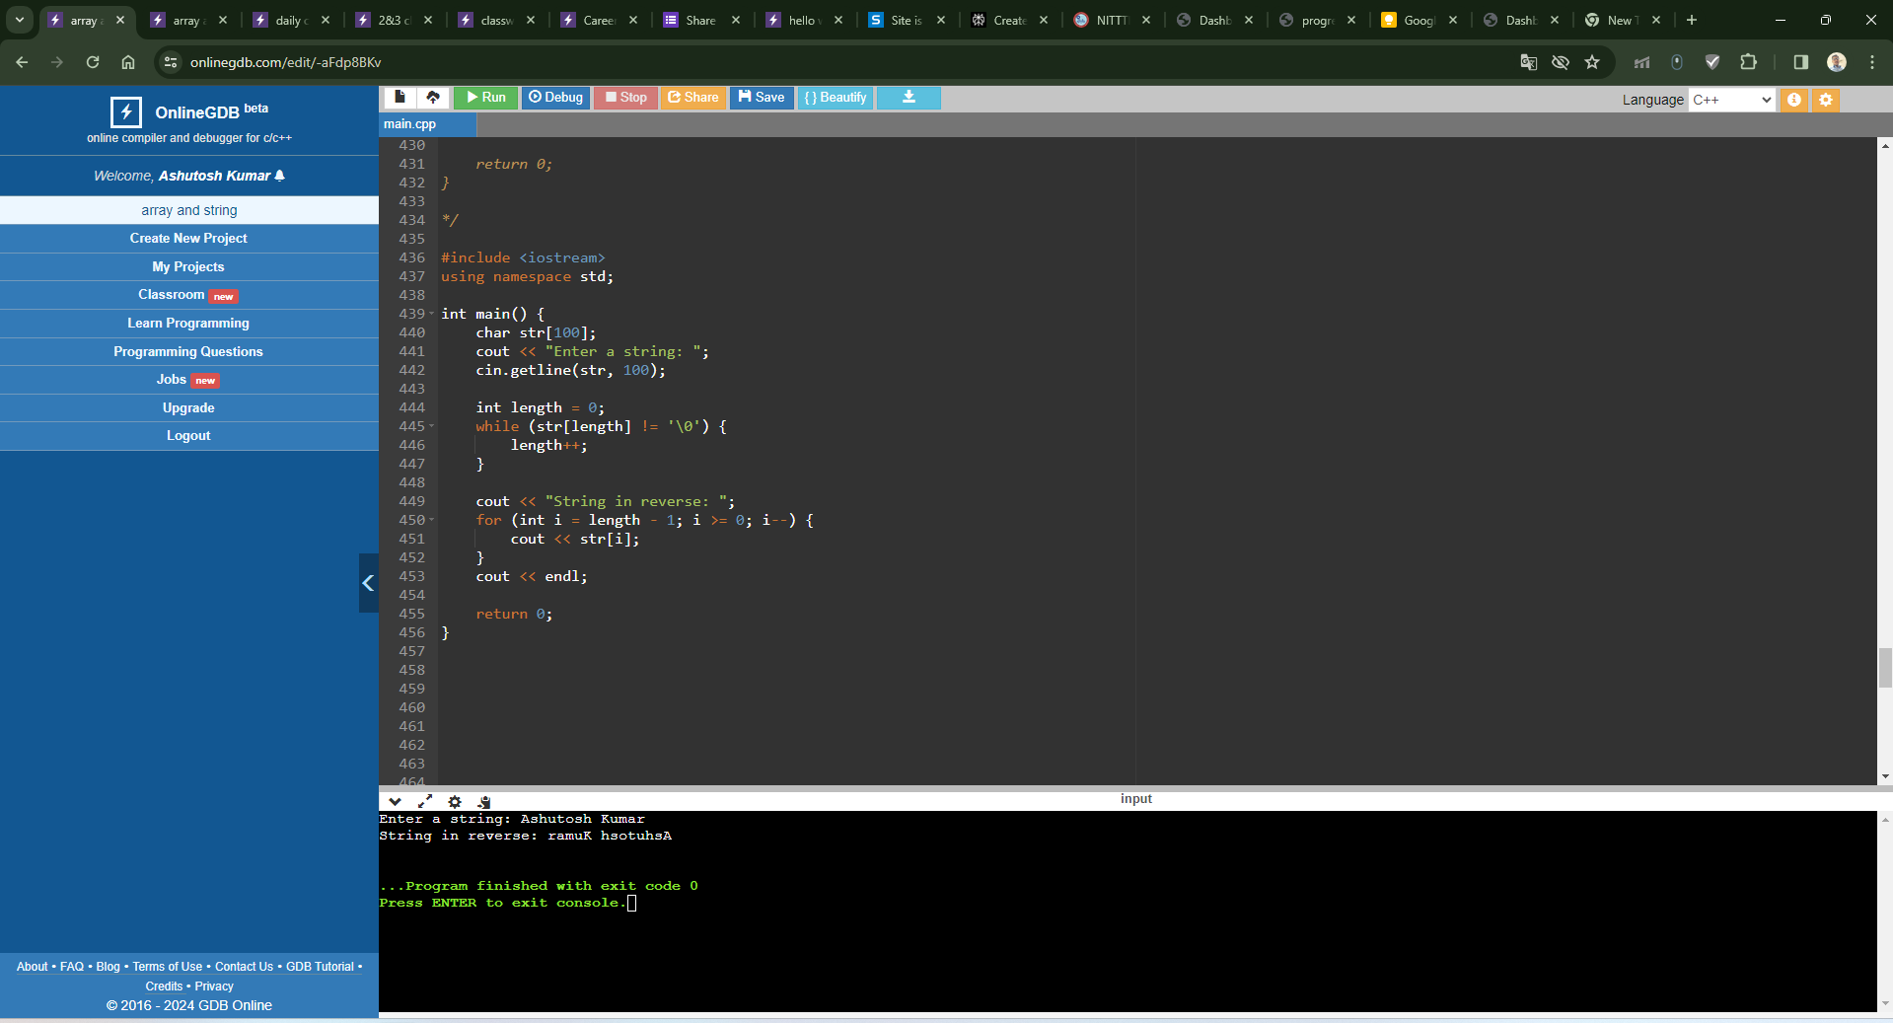
//3. Write a program to count number of words in string.
#include <iostream>
using namespace std;

int main() {
char str[100];
cout << "Enter a string: ";
cin.getline(str, 100);

int count = 1;
for (int i = 0; str[i] != '\0'; i++) {
if (str[i] == ' ') {
count++;
}
}

cout << "Number of words in the string: " << count << endl;
return 0;
}

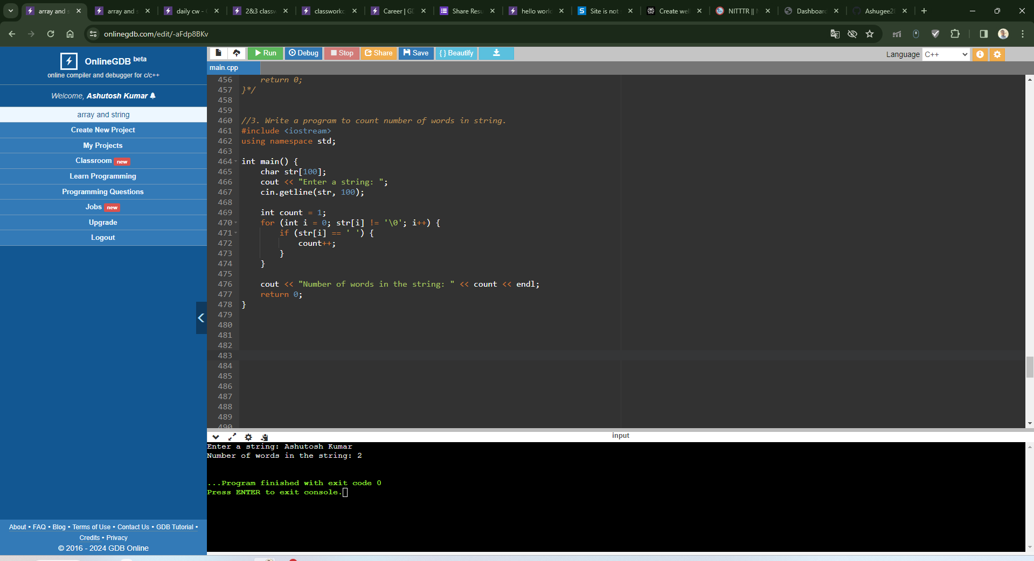
//4. Write a program to concatenate one string contents to another.

#include <iostream>
#include <cstring>
using namespace std;

int main() {
char str1[100], str2[100];
cout << "Enter the first string: ";
cin.getline(str1, 100);
cout << "Enter the second string: ";
cin.getline(str2, 100);

strcat(str1, str2);

cout << "Concatenated string: " << str1 << endl;
return 0;
}
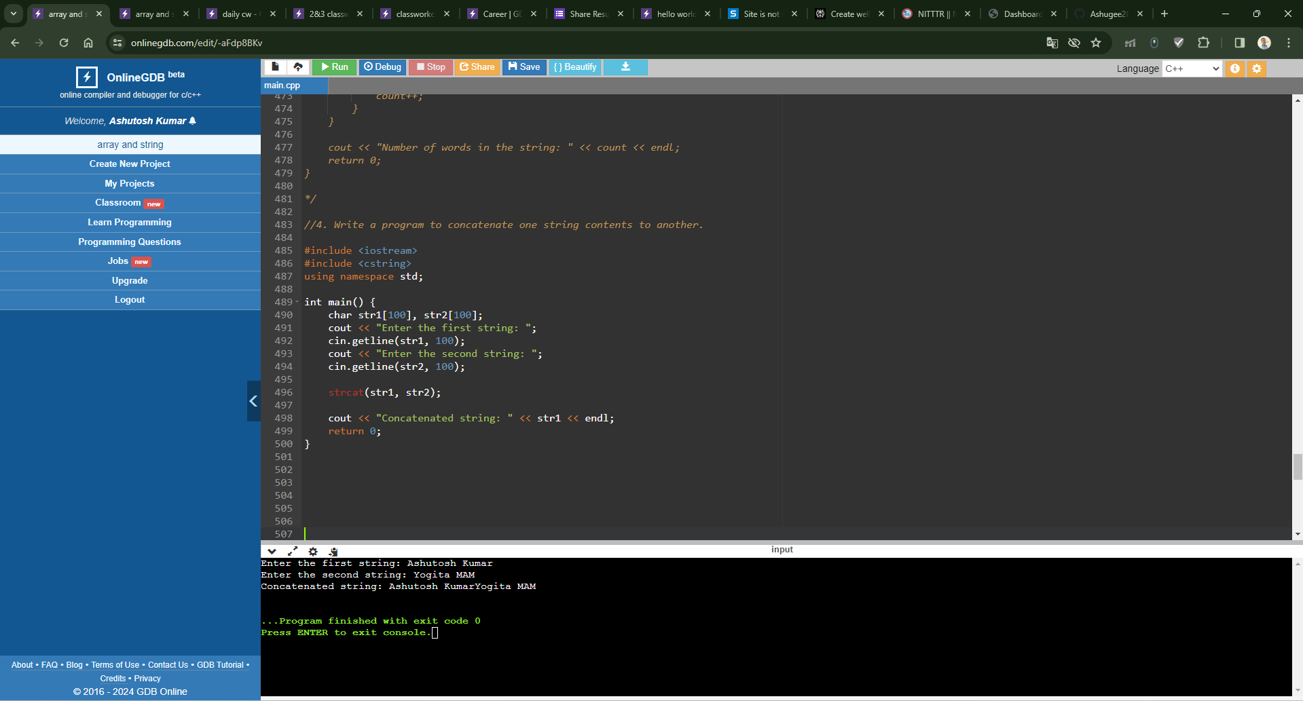
//5. Write a program to compare two strings they are exact equal or not.

#include <iostream>
#include <cstring>
using namespace std;

int main() {
char str1[100], str2[100];
cout << "Enter the first string: ";
cin.getline(str1, 100);
cout << "Enter the second string: ";
cin.getline(str2, 100);

if (strcmp(str1, str2) == 0) {
cout << "Both strings are equal." << endl;
} else {
cout << "Strings are not equal." << endl;
}

return 0;
}
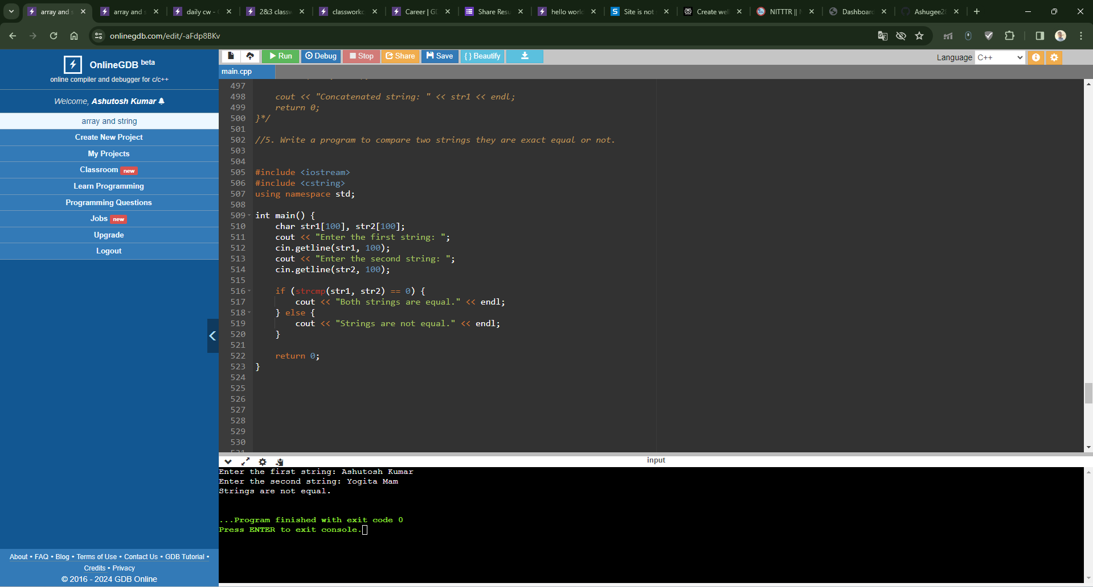
//6. Write a program to check a string is palindrome or not.

#include <iostream>
#include <cstring>
using namespace std;

int main() {
char str[100];
cout << "Enter a string: ";
cin.getline(str, 100);

int length = strlen(str);
bool isPalindrome = true;

for (int i = 0; i < length / 2; i++) {
if (str[i] != str[length - i - 1]) {
isPalindrome = false;
break;
}
}

if (isPalindrome) {
cout << "String is a palindrome." << endl;
} else {
cout << "String is not a palindrome." << endl;
}

return 0;
}
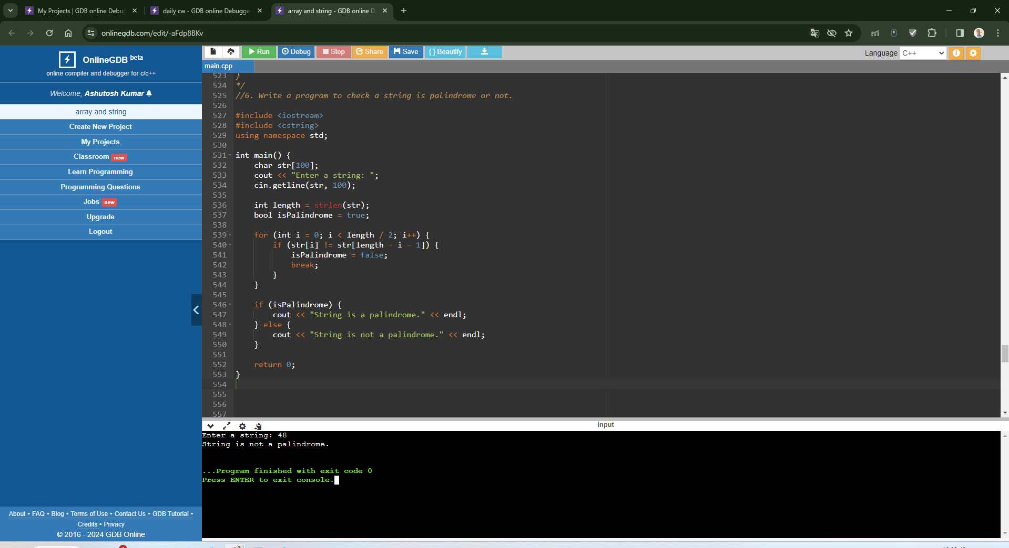

//7. Write a program to find a substring within a string. If found display its starting position.

#include <iostream>
#include <cstring>
using namespace std;

int main() {
char str[100], substr[100];
cout << "Enter the main string: ";
cin.getline(str, 100);
cout << "Enter the substring to find: ";
cin.getline(substr, 100);

char *pos = strstr(str, substr);
if (pos != nullptr) {
cout << "Substring found at position: " << pos - str << endl;
} else {
cout << "Substring not found in the main string." << endl;
}

return 0;
}
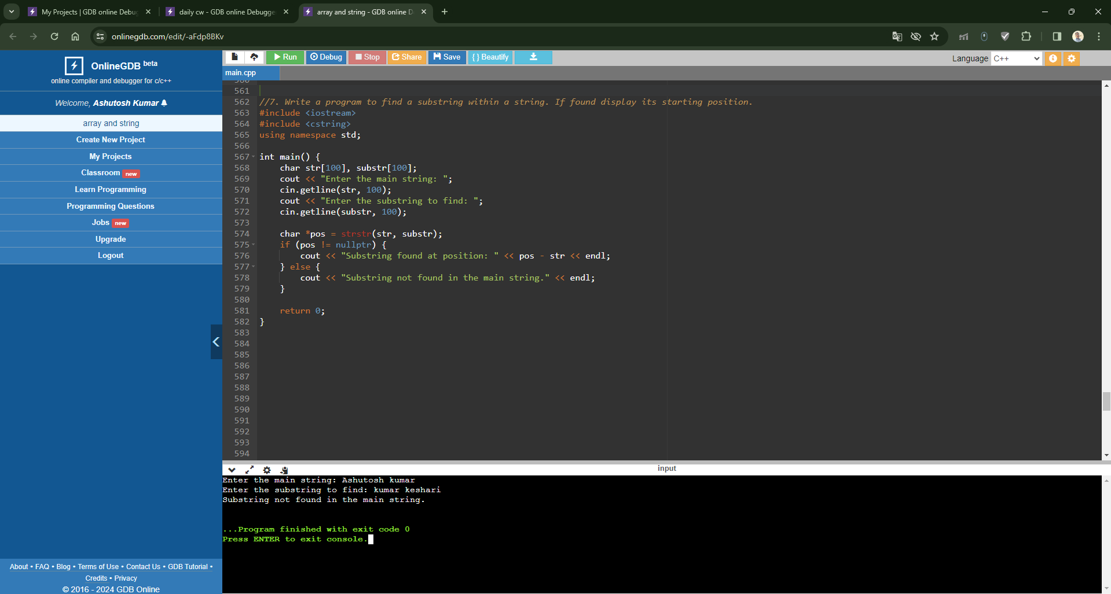
//8. Write a program to reverse a string.
#include <iostream>
#include <cstring>
using namespace std;

int main() {
char str[100];
cout << "Enter a string: ";
cin.getline(str, 100);

int length = strlen(str);
cout << "Reversed string: ";
for (int i = length - 1; i >= 0; i--) {
cout << str[i];
}
cout << endl;

return 0;
}
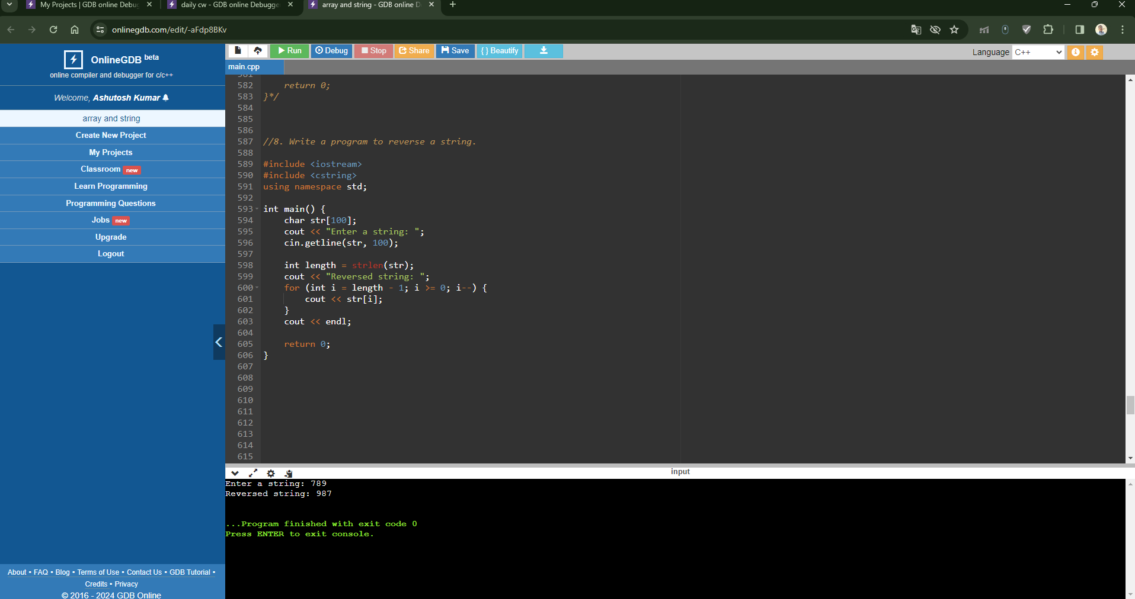
//9. Write a program to convert a string in lowercase.
#include <iostream>
#include <cstring>
using namespace std;

int main() {
char str[100];
cout << "Enter a string: ";
cin.getline(str, 100);

for (int i = 0; str[i] != '\0'; i++) {
if (str[i] >= 'A' && str[i] <= 'Z') {
str[i] += 32; // Convert uppercase to lowercase by adding 32 to ASCII value
}
}

cout << "String in lowercase: " << str << endl;
return 0;
}
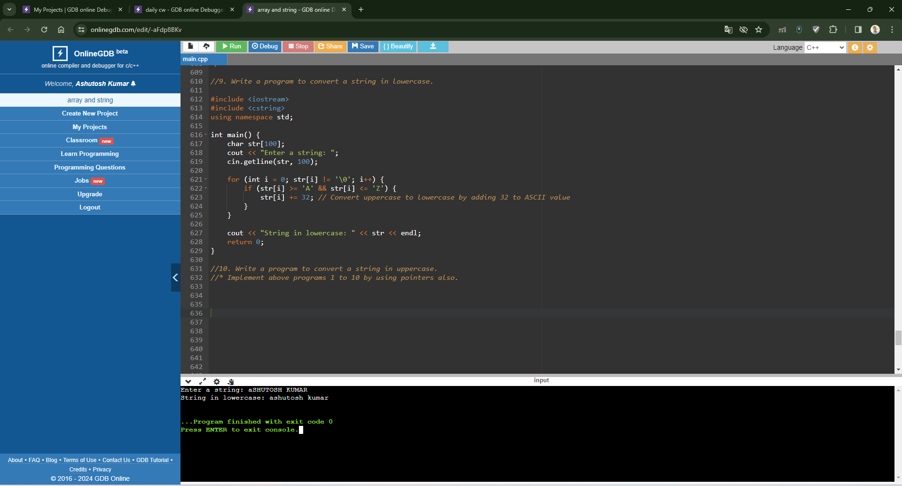
//10. Write a program to convert a string in uppercase.
#include <iostream>
#include <cstring>
using namespace std;

int main() {
char str[100];
cout << "Enter a string: ";
cin.getline(str, 100);

for (int i = 0; str[i] != '\0'; i++) {
if (str[i] >= 'a' && str[i] <= 'z') {
str[i] -= 32; // Convert lowercase to uppercase by subtracting 32 from ASCII value
}
}

cout << "String in uppercase: " << str << endl;
return 0;
}
